**TOPIC 2 : BRUTE FORCE**

**EXPERIMENT-2.1 sorts the list**

**EXPERIMENT-2.2 Count Selection Sort Explanation + Code**

**EXPERIMENT-2.4 Insertion Sort with Duplicates**

**EXPERIMENT-2.7 First Occurrence of Substring**

**EXPERIMENT-2.8 Find Substrings in List**

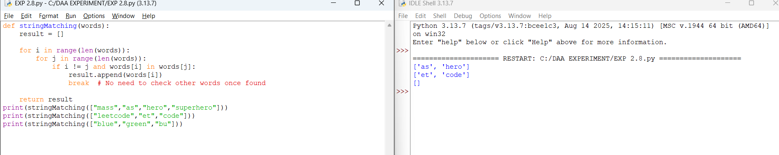

**EXPERIMENT-2.9 Closest Pair of Points (Brute Force)**

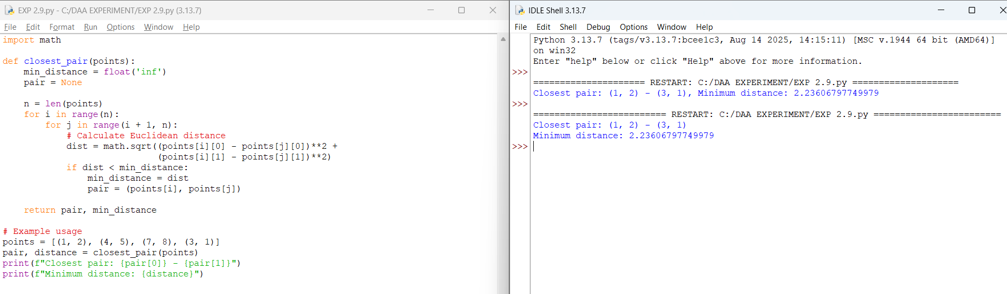

**EXPERIMENT-2.10 Convex Hull (Brute Force)**

**EXPERIMENT-2.11 Convex Hull (Simple Example)** 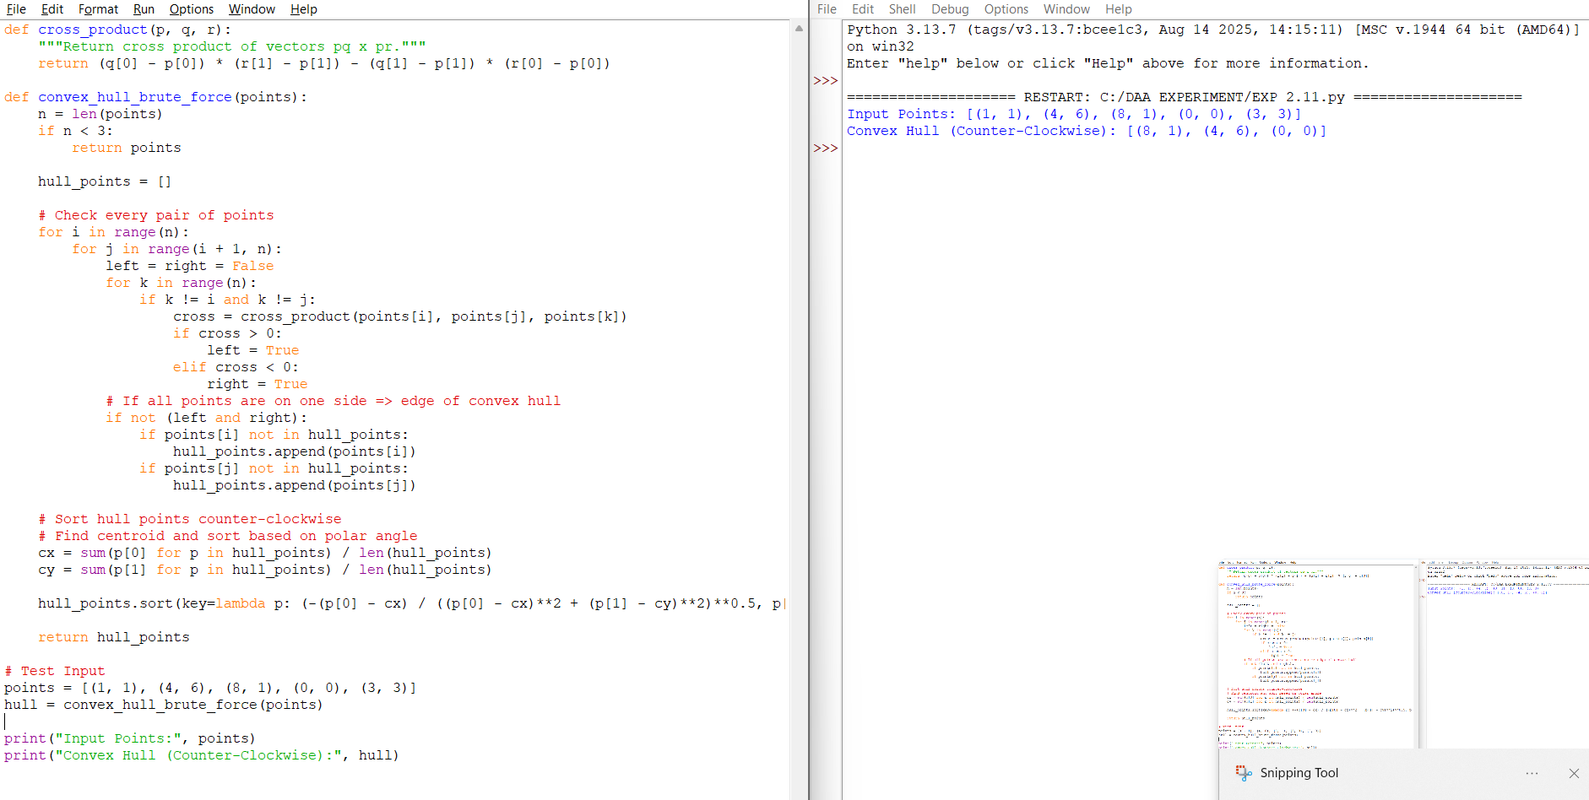

**EXPERIMENT-2.14 Knapsack Problem using exhaustive search (brute force)**

